Union assignments

Mandatory
- Refer the code below and comment on size of the given structure considering
  - Structure as union
  - Structure as struct
  - arr
  - uarr

___ Job
{
char name[32];
unsigned short ucount;
float salary;
int workerNo;
char *orgname;
};

___ Job myvar; //could of union or of struct
Struct Job arr[10];
Union Job uarr[10];

- In the case of a union, all members share the same memory space. The size of the union is determined by the size of its largest member. Here, the largest member is name[32], which is 32 bytes, so the size of the union is 32 bytes.
- In the case of a struct, each member occupies its own space, and the total size of the structure is the sum of the sizes of its individual members. Here the size is 46 bytes
- An array of structs will take 10 * sizeof(struct Job) bytes. Since sizeof(struct Job) is 48 bytes, the size of the array will be:sizeof(arr); // 10 * 48 = 480 bytes

- An array of unions will take 10 * sizeof(union Job) bytes. Since sizeof(union Job) is 32 bytes, the size of the array will be:sizeof(uarr); // 10 * 32 = 320 bytes

- Refer Job datastructure in Q#1 above. Using uarr, perform below operations.
  - Read and store salary
  - Read and store workerNo
Comment on values of output if salary and workerNo are printed in order. Justify your statement.
Ans: we are using a union, the members salary and workerNo share the same memory. After assigning a value to salary, the salary field occupies the union's memory location. When we assign a value to workerNo, the memory of salary is overwritten by workerNo because they share the same space
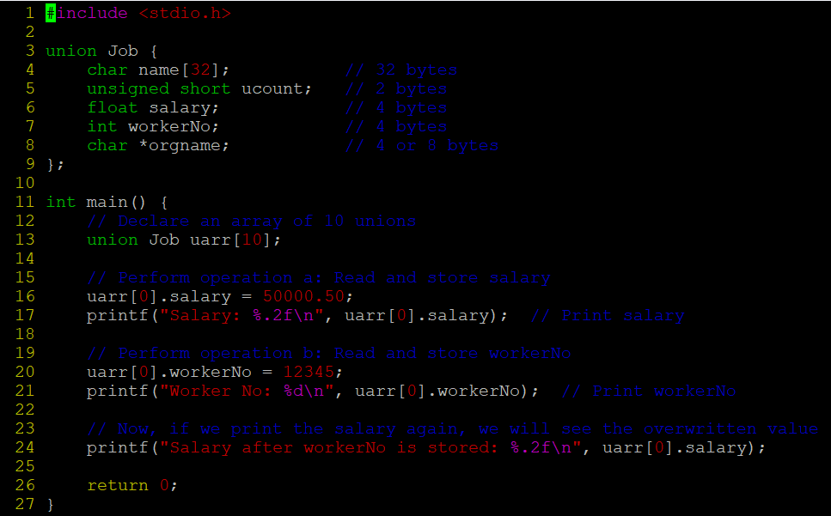
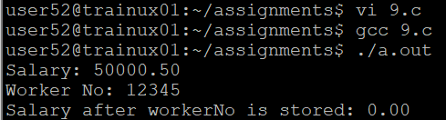
- Refer Job datastructure in Q#1 above. Assume that myvar is a structure variable. If I need to place 2 bytes (i.e 0x0102) as ucount using a char *ptr then list all possible statements that can be used in _____.
[Let solutions include cases such as
    - using base address of ucount
    - using relative address of ucount w.r.t to base address of myvar]
int main()
{
char *ptr = &myvar;

___________ = 0x01;
___________ = 0x02

}

